O-Ran Software Community  
 “A” Release Requirements

Contents

Introduction 3

1. O-RAN SC Release “A” 3

A. Release “A” schedule dates 3

B. Target Sprint Timeline 3

2. Release “A” Objective 4

C. Project repos 5

3. Use Case Definitions 7

A. Project Use Case Descriptions 7

B. Dashboard/portal 7

C. Non-RT RIC (RPGF/ONAP) 8

D. Near-RT RIC 9

E. RIC xApps 15

F. Simulators 17

G. Integration and Testing 18

H. O-RAN Interface Compliance Testing 19

I. O-RAN Use Case Testing 20

J. O-CU 20

K. O-DU 20

4. O-RAN Software Project Objectives 21

A. Non-RT RIC: Orchestration and Automation with ONAP 21

B. xAPPs 22

C. O-CU 23

D. O-DU 23

E. O-RU 23

5. External and Common Software Projects 24

A. Virtualization and acceleration Layer 24

B. Operations, Administrations, and Maintenance (OA&M) 24

C. Common Logging and Tracing 24

D. Common Software Library and Tools. 24

6. Integration and Test “A” Objectives 24

A. End to End O-RAN Use Case Testing 24

a. Software testing should be covered by automated software testing using robot framework or other tools. https://robotframework.org/ 24

7. Simulator Objectives 24

A. Simulators for O-RAN components, interfaces, and messages. 25

B. Simulators for external components that interoperate with O-RAN 25

C. Simulators for User Equipment (UE) 25

8. Addendums 25

A. Contributors 25

B. Definitions 26

C. Near-RT RIC component details 26

# Introduction

O-RAN Software Community (O-RAN SC ) is a Linux Foundation Project in collaboration with the O-RAN Alliance to create an open source software solution that implements a Radio Access network implementation that aligned with O-RAN Alliance specifications.

Each release for the O-RAN SC will need to define the scope of the software for each release. Each release planning will need to set goals that advance the software but works within the limitations of the available O-RAN alliance specification, testable functions, and software development resources. Open source projects work to accomplish a solution over multiple releases, however each release should have clear objectives that advance the software projects and end to end stack objectives.

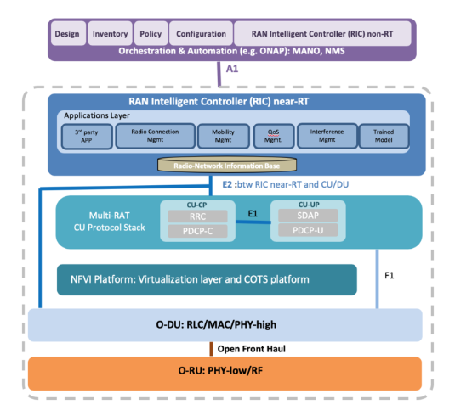

Figure 1 - O-RAN architecture

## O-RAN SC Release “A”

### Release “A” schedule dates

M0 (6/3) to M1 (6/29). This M0 involves identifying Epics, breaking down Epics into User Stories and Tasks, map Epics and US/Task to projects and dependencies, and review and finalize tasks and sub tasks in preparation for the software developers and testers to plan development sprints.

### Target Sprint Timeline

This sprint calendar is show below in Figure 2

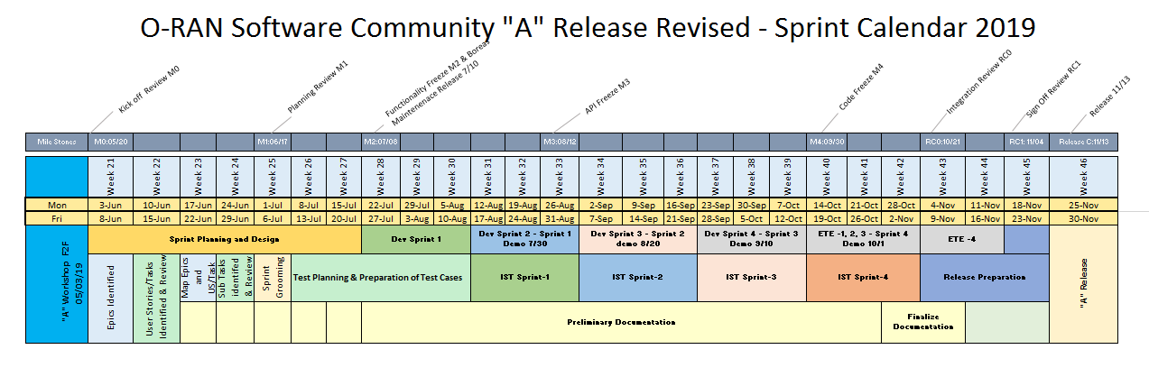

Figure 2 - Sprint calendar

## Release “A” Objective

* Demonstrate a working reference implementation of a full end-to-end O-RAN stack. The release will have some items identified as stretch goals.
  + Non-RT RIC (e.g., ONAP) implementing a basic A1 interface
  + Near-RT RIC framework implementing (see Fig. 1)
    - Application/microservices framework to host multiple xApps (e.g., UE manager)
    - A message bus to publish and subscribe messages inside RIC
    - A1 mediator to relay basic policies from ONAP to RIC
    - E2 Termination agent to interface with O-CU
    - R-NIB DBaaS to store RAN state information
    - E2 manager to transact E2 data into the R-NIB
  + Dashboard to display FM and PM counters from RIC
  + A virtualization layer based on COTS platform (e.g., Akraino)
  + A basic E2 interface agent via a simulator (gNb side)
  + O-CU implementation of an integrated eNB
  + O-DU implementing
    - L1 functional blocks
    - L2 functional blocks
  + Open Front Haul implementation
    - Node level and inter-node conformance

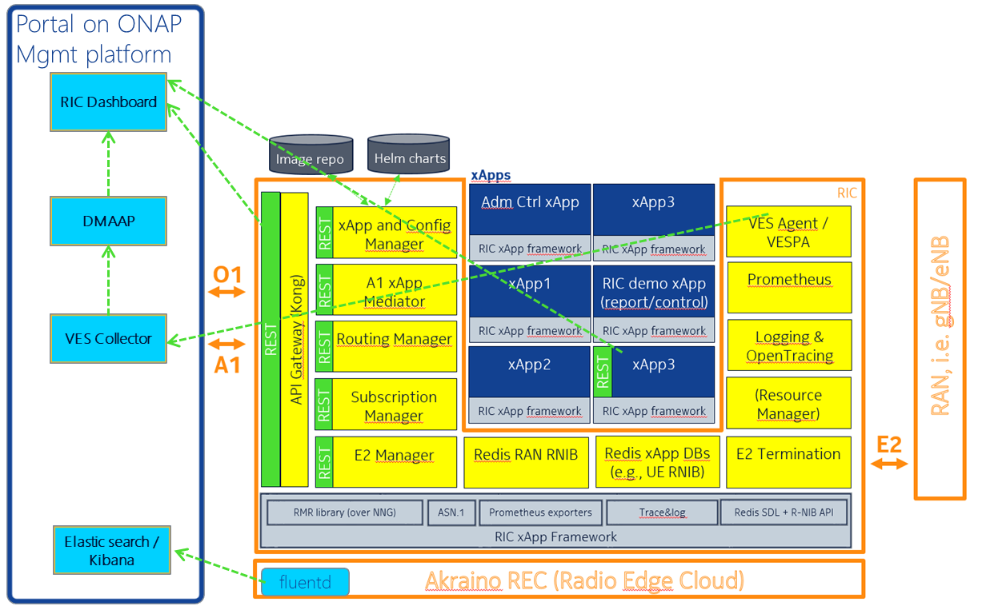

Figure 1 - near-RT RIC open source platform

Figure 1 shows an example of the near-RT RIC architecture platform deployed on a virtualized radio edge cloud (REC) infrastructure. The RIC allows xApps to be deployed and managed. The RIC also connects southbound to the RAN via E2 and northbound via A1.

### Project repos

|  |  |  |  |
| --- | --- | --- | --- |
| Project Name | Project Key | PTL | Seed Code Repos |
| Non-realtime RAN Intelligent Controller | RICNRT | E/// |  |
|  |
| RAN Intelligent Controller Applications | RICAPP | AT&T | ric-app/admission |
| ric-app/reporter |
|  |
| RAN Intelligent Controller | RIC | Thoralf, Nokia | com/asn1 |
| com/golog |
| com/log |
| ric-plt/a1 |
| ric-plt/appmgr |
| ric-plt/dbaas |
| ric-plt/dbaas/hiredis-vip |
| ric-plt/e2 |
| ric-plt/e2mgr |
| ric-plt/lib/rmr |
| ric-plt/rtmgr |
| ric-plt/sdl |
| ric-plt/sdl/config |
| ric-plt/sdlgo |
| ric-plt/sdlpy |
| ric-plt/submgr |
| ric-plt/utils |
| ric-plt/xapp-frame |
|  |
| O-RAN Central Unit | OCU | CMCC | (China Mobile integrated eNB contribution) |
|  |
| O-RAN Distributed Unit | ODU | Radisys | (Intel L1 contribution) |
| (Radisys L2 contribution) |
| Commscope? |
| O-RAN RU | ORU |  | Out of scope for Rel A |
| Operations Administration Management Apparatus | OAM |  | portal/ric-dashboard |
|  |
| Simulation | SIM | AT&T | (AT&T RAN side E2 simulator) |
|  |
| Infrastructure | INF | Lenovo | aal/lib |
| aal/logic |
| aal/mgmt |
| aal/virt |
| (Inspur infra monitoring contribution) |
| Akraino/blueprint |
| Integration and Testing | INT | AT&T | it/dep |
| it/dev |
| it/test |
| OTF |
| Documentation | DOC |  | doc |
|  |

## Use Case Definitions

The integration and test effort will focus on testing the requirements documented in each release. This will focus on end to end use case testing.

### Project Use Case Descriptions

The use cases are categorized into two categories, namely platform and service. The following template is used to describe a use case:

|  |  |
| --- | --- |
| Title |  |
| Description |  |
| Acceptance Criteria |  |
| Source |  |

### Dashboard/portal

|  |  |
| --- | --- |
| Title | [OAM-A-F01] RIC Dashboard |
| Description | As a RIC Operator I need an initial way to manage a single RIC instance for monitoring and control during evaluation of the RIC in a network scenario. [RICPLT-R1-F3] |
| Acceptance Criteria | User interface with connectivity to a RIC instance via pre-standard interfaces. |
| Source | RIC Co-Create R1 (AT&T) |

|  |  |
| --- | --- |
| Title | [OAM-A-F02] RIC Connectivity Dashboard |
| Description | Enable control of connecting/disconnecting the RIC to/from a gNB (via the E2 Manager) |
| Acceptance Criteria | User Interface to add or delete gNodeB E2 endpoints to the scope of a RIC instance. |
| Source | RIC Co-Create R1 (AT&T) |

|  |  |
| --- | --- |
| Title | [OAM-A-F03] RIC Service Assurance Dashboard |
| Description | Display metrics from each xApp (how to make this generic TBD - JSON/yang/?) |
| Acceptance Criteria | User Interface to view alarms (optional) and performance metrics collected from a RIC Instance and data received from any of its xAPPs. |
| Source | RIC Co-Create R1 (AT&T), alarms in Release B |

|  |  |
| --- | --- |
| Title | [OAM-A-F04] RIC Xapp management Dashboard |
| Description | Provide a method to LCM (onboard, deploy), configure Xapps in a generic way (e.g., yang definition of the interface) |
| Acceptance Criteria | User Interface to compose commands or data to exposed RIC APIs. |
| Source | RIC Co-Create R1 (AT&T) |

|  |  |
| --- | --- |
| Title | [OAM-A-F05] O-RAN-SC Certification Dashboard |
| Description | Provide a Portal for viewing previously executed tests and to visually show current tests in progress. |
| Acceptance Criteria | User Interface to view test already completed, in progress, or scheduled to be executed. |
| Source | OTF (AT&T) |

### Non-RT RIC (RPGF/ONAP)

|  |  |
| --- | --- |
| Title | [RICNRT-A-F10] Enable the RPGF to send policy guidance to the xApp via the A1 interface |
| Description | As a Service Management and Orchestrator I need to be able to determine appropriate policy guidance set of values that needs to be applied to a given instance of an xApp, and to send these values via the A1 interface in order to update the policies in use by that xApp. |
| Acceptance Criteria | Acceptance criteria is to demonstrate an ability to generate policy guidance values, send these over the A1 interface to a target set of xApps, have these xApps make changes accordingly to the values, and observe behavior by the xApps consistent with the sent policy guidance |
| Source | OSC “B” (TBD) |

|  |  |
| --- | --- |
| Title | [RICNRT-A-F20] Enable the RPGF to receive and process telemetry from an xApp sent via the A1 interface |
| Description | As a Service Management and Orchestrator I need to be able to receive, process and potentially store telemetry sent over the A1 interface, |
| Acceptance Criteria | Demonstrate an ability to receive telemetry sent over the A1 interface, make changes accordingly, and observe behavior by the RPGF consistent with the received telemetry |
| Source | OSC “B” (TBD) |

|  |  |
| --- | --- |
| Title | [RICNRT-A-F30] Enable the RPGF to collect and process telemetry from an xApp sent via the O1 Interface |
| Description | As a Service Management and Orchestrator I need to be able to receive, process and potentially store telemetry sent over the O1 interface, |
| Acceptance Criteria | Demonstrate an ability to receive telemetry sent over the O1 interface, make changes accordingly, and observe behavior by the RPGF consistent with the received telemetry |
| Source | OSC “B” (TBD) |

|  |  |
| --- | --- |
| Title | [RICNRT-A-F40] Support an extensible RPGF Platform |
| Description | As a Service Management and Orchestrator I need to be able to support an extensible RPGF platform that can support the dynamic addition, (re)configuration, (re)activation, execution, deactivation, and removal of a discrete sets of functionality packaged as discrete units (containers) |
| Acceptance Criteria | Demonstrate the ability to add, (re)configure, (re)activate, execute, deactivate and remove a discrete units of functionality |
| Source | OSC “B” (TBD) |

|  |  |
| --- | --- |
| Title | [RICNRT-A-F50] Develop Test Strategy for the Non-RT RIC |
| Description | As an RGPF Certification tester I need to have a testing strategy that can isolate the RPGF under test and verify it conforms to RIC Architecture and O-RAN Architecture requirements. |
| Acceptance Criteria | BPEL describing RPGF test procedure can execute as a Camunda flow. |
| Source | OSC “B” (TBD) |

### Near-RT RIC

|  |  |
| --- | --- |
| Title | [RIC-A-F01] RIC Connects to gNodeB |
| Description | [RICPLT-R1-F1] RIC shall control gNB using E2 interface |
| Acceptance Criteria | RIC successfully subscribes to gNodeB over E2. |
| Source | RIC Co-Create R1 (Nokia) |

|  |  |
| --- | --- |
| Title | [RIC-A-F02] RIC functions are guided through pre-spec A1 |
| Description | [RICPLT-R1-F2] RIC shall be managed through NB interface (A1) |
| Acceptance Criteria | A1 message sent to RIC is transformed into E2 Control message(s). |
| Source | RIC Co-Create R1 (AT&T) |

|  |  |
| --- | --- |
| Title | [RIC-A-F03] "Big Red Button" |
| Description | [RICPLT-R1-F4] Provide the ability to quickly disconnect RIC from RAN during production market trials in case harm is detected. |
| Acceptance Criteria | RIC responds to disconnect message by severing all E2 communications. All communications between gNB and RIC are stopped. |
| Source | RIC Co-Create R1 (Nokia) |

|  |  |
| --- | --- |
| Title | [RIC-A-F04] Provide Data Storage Abstraction Layer |
| Description | [RICPLT-R1-E1] DBaaS/SDL/Redis |
| Acceptance Criteria |  |
| Source | RIC Co-Create R1 (Nokia) |

|  |  |
| --- | --- |
| Title | [RIC-A-F05] Provide RIC Inter-module communications |
| Description | [RICPLT-R1-E2] RMR |
| Acceptance Criteria |  |
| Source | RIC Co-Create R1 (Nokia) |

|  |  |
| --- | --- |
| Title | [RIC-A-F06] Provide Standardized logging library |
| Description | Logging (REC already can ship outside, we might re-use that) |
| Acceptance Criteria |  |
| Source | RIC Co-Create R1 (AT&T) |

|  |  |
| --- | --- |
| Title | [RIC-A-F07] Support event trace reporting |
| Description | Tracing - support for openTracing |
| Acceptance Criteria |  |
| Source | RIC Co-Create R1 (Nokia) |

|  |  |
| --- | --- |
| Title | [RIC-A-F08] Provide High-Available Architecture |
| Description | HA (DBaaS) |
| Acceptance Criteria | Single failure of a container are handled by container restart without loss of significant data (like subscriptions). DB must provide a redundancy setup in which replicas can take over in case of a single failure. Generally the RIC platform must handle the failure of a k8s node (assuming that we have all properly distributed over 3 nodes) as well as a single container instance; use a full system restart to reset the RIC to an initial state |
| Source | RIC Co-Create R1 (Nokia) |

|  |  |
| --- | --- |
| Title | [RIC-A-F09] Provide DBaaS API for multiple development languages |
| Description | DB libraries for other language |
| Acceptance Criteria |  |
| Source | RIC Co-Create R1 (Nokia) |

|  |  |
| --- | --- |
| Title | [RIC-A-F10] Recovery after connection failure restoral |
| Description | All component should be restart automatically and reconnect |
| Acceptance Criteria |  |
| Source | RIC Co-Create R2 (Nokia) |

|  |  |
| --- | --- |
| Title | [RIC-A-F11] Rainy Day Interface Handling |
| Description | Retry strategy/policy |
| Acceptance Criteria |  |
| Source | RIC Co-Create R2 (Nokia) |

|  |  |
| --- | --- |
| Title | [RIC-A-F13] Initial Performance Metrics |
| Description | Metrics |
| Acceptance Criteria |  |
| Source | RIC Co-Create R1 (Nokia) |

|  |  |
| --- | --- |
| Title | [RIC-A-F14] Improve Component Implementation Performance |
| Description | Performance area (let's see where we are at end of R0) - do we need to improve latencies? |
| Acceptance Criteria |  |
| Source | RIC Co-Create R2 (Nokia) |

|  |  |
| --- | --- |
| Title | [RIC-A-F15] Provide Platform Healthcheck |
| Description | Something in area of testability |
| Acceptance Criteria |  |
| Source | RIC Co-Create R2 (Nokia) |

|  |  |
| --- | --- |
| Title | [RIC-A-F16] Map E2 Messages to IDs |
| Description | Provide a general way to handle and manage RIC message types (each type maps to an integer) that is aligned with 3GPP message types where appropriate. Right now (R0) message types are constants that are defined with integer values. However, there is a need to use symbolic/string names for the message types in the Dashboard and xApp Manager. Initial though: a more general (e.g., JSON) descriptor that can be translated into language specific header files. |
| Acceptance Criteria |  |
| Source | RIC Co-Create R1 (Nokia) |

|  |  |
| --- | --- |
| Title | [RIC-A-F16] Support IPv6 in the E2 Manager |
| Description | Support IPv6 address for the gNB (E2 Manager) |
| Acceptance Criteria |  |
| Source | RIC Co-Create R1 (Nokia) |

|  |  |
| --- | --- |
| Title | [RIC-A-F17] Support IPv6 in the E2 Term |
| Description | Support IPv6 address for the gNB (E2 Term) |
| Acceptance Criteria |  |
| Source | RIC Co-Create R1 (Nokia) |

|  |  |
| --- | --- |
| Title | [RIC-A-F18] Maintaining Message Routing after Recovery |
| Description | If an xApp fails and recovers (thanks to K8s) and its IP address changes, call Routing Manager to update the routing rules (TBD - maybe using "service name" in routing rules is sufficient to handle failure and recovery) |
| Acceptance Criteria |  |
| Source | RIC Co-Create R2 (Nokia) |

|  |  |
| --- | --- |
| Title | [RIC-A-F19] Maintain Subscriptions |
| Description | Receive subscription based routing updates from Subscription Manager. |
| Acceptance Criteria |  |
| Source | RIC Co-Create R1 (Nokia) |

|  |  |
| --- | --- |
| Title | [RIC-A-F20] Connect xAPP to Network Elements |
| Description | Populate initial routes for an xApp when it is deployed |
| Acceptance Criteria |  |
| Source | RIC Co-Create R1 (Nokia) |

|  |  |
| --- | --- |
| Title | [RIC-A-F21] Provide RAN to E2 Term Mapping |
| Description | Support routing to the correct E2 Termination instance based on RAN id |
| Acceptance Criteria |  |
| Source | RIC Co-Create R1 (Nokia) |

|  |  |
| --- | --- |
| Title | [RIC-A-F22] Persist Routing for Recovery/Restart |
| Description | Persist routing information in DB |
| Acceptance Criteria |  |
| Source | RIC Co-Create R2 (Nokia) |

|  |  |
| --- | --- |
| Title | [RIC-A-F24] Restore Routing after Restart or Recovery |
| Description | Handle Routing Manager restart after failure |
| Acceptance Criteria |  |
| Source | RIC Co-Create R2 (Nokia) |







|  |  |
| --- | --- |
| Title | [RIC-A-F27] RIC supports A1 Routing |
| Description | Provide ability to route A1 messages received from the NMS to the appropriate message processing application (xAPP) via Kong or RMR |
| Acceptance Criteria |  |
| Source | RIC Co-Create R1 (AT&T) |

|  |  |
| --- | --- |
| Title | [RIC-A-F28] Provide NBI for configuring an xAPP |
| Description | Provide an API to the Ops Portal (REST or something different) |
| Acceptance Criteria |  |
| Source | RIC Co-Create R1 (Nokia) |

|  |  |
| --- | --- |
| Title | [RIC-A-F29] Support xAPP config prior to xAPP launch |
| Description | When receive a configuration update message, populate the payload in the right Redis namespace. |
| Acceptance Criteria |  |
| Source | RIC Co-Create R1 (Nokia) |

|  |  |
| --- | --- |
| Title | [RIC-A-F30] Provide persistent store of xAPP Config |
| Description | Possibly further steps needed after data is in Redis (e.g. ConfigMap creation) |
| Acceptance Criteria |  |
| Source | RIC Co-Create R1 (Nokia); In Release B |

|  |  |
| --- | --- |
| Title | [RIC-A-F31] Ability to dynamically apply container configmap |
| Description | . Ability to apply a new config to a running Xapp container |
| Acceptance Criteria |  |
| Source | RIC Co-Create R1 (Nokia) |

|  |  |
| --- | --- |
| Title | [RIC-A-F32] xAPP needs to be able to receive RAN Messages |
| Description | Receive E2 Subscription message from RMR, compare the subscription to existing subscriptions based on the targeted gNB (from RMR header) and the E2 Subscription message payload. |
| Acceptance Criteria |  |
| Source | RIC Co-Create R1 (Nokia) |

|  |  |
| --- | --- |
| Title | [RIC-A-F33] RIC supports control loop latency measures (RAN to RIC to RAN via E2 termination) |
| Description | Collect the latency for each control loop execution, report min/max/avg latency for each control loop via the Prometheus metrics collection; Correlator is the E2 Call Process ID (octet) |
| Acceptance Criteria |  |
| Source | RIC Co-Create R1 (Nokia) |

|  |  |
| --- | --- |
| Title | [RIC-A-F34] Provide Intra-RIC Tracing |
| Description | RMR instrumentation for open-tracing (depends on E2 termination to start using it) – Dependency on other teams to actually include open-trace support in RMR (for RMR: Espoo 2 writes prototype and demonstrate usage and AT&T platform team then integrates that into RMR formally), E2 termination, one xApp (Nokia), the open-source xApp. |
| Acceptance Criteria |  |
| Source | RIC Co-Create R1 (Nokia) |

|  |  |
| --- | --- |
| Title | [RIC-A-F35] RIC supports fault reporting |
| Description | RIC should emit alarm in case of faults (optional); should have some way to report alarm (logs) as faults appear and report if they disappear |
| Acceptance Criteria |  |
| Source | RIC Co-Create R1 (Nokia); |

|  |  |
| --- | --- |
| Title | [RIC-A-F36] RIC as an Appliance (PNF) supports platform reporting |
| Description | Enable measuring and reporting on platform statistics |
| Acceptance Criteria |  |
| Source | RIC Co-Create R1 (Nokia) |

|  |  |
| --- | --- |
| Title | [RIC-A-F37] RIC needs to be able to report on Infrastructure, Platform, and Applications independently. |
| Description | Support different granularities (apps, platform) |
| Acceptance Criteria |  |
| Source | RIC Co-Create R1 (Nokia) |

|  |  |
| --- | --- |
| Title | [RIC-A-F38] Support O1 performance reporting |
| Description | Support platform performance metrics |
| Acceptance Criteria |  |
| Source | RIC Co-Create R1 (Nokia) |

|  |  |
| --- | --- |
| Title | [RIC-A-F39] RIC must support tracing/logging using (sub)session IDs |
| Description | Infrastructure must conform to logging guidelines (RIC, xApp, RPGF) |
| Acceptance Criteria |  |
| Source | RIC Co-Create R1 (Nokia) |

|  |  |
| --- | --- |
| Title | [RIC-A-F41] The RIC as a platform needs to be independently testable. |
| Description | Develop Test Strategy for the RIC Platform |
| Acceptance Criteria |  |
| Source | RIC Co-Create R1 (Nokia) |

### RIC xApps

|  |  |
| --- | --- |
| Title | [RICAPP-A-F01] Admission Control xApp |
| Description | As a Service Operator I need a basic admission Control function (xApp) to be deployed to a RIC for the purpose of controlling user access to the 5G network elements. |
| Acceptance Criteria | xAPP example that can be deployed to the RIC, interacts with gNodeBs and is able to receive configuration and policy from an RPGF. |
| Source | RIC Co-Create R1 (AT&T) |

|  |  |
| --- | --- |
| Title | [RICAPP-A-F02] Measurement, MCxapp |
| Description | As a Service Operator I need a RAN function to expose internal RAN measurements like the core Network Exposure Function (NEF) such that I can see some of the fine grain internal measurements occurring in the RAN management functions that are not available in the core. |
| Acceptance Criteria | Demonstrate collection of RAN metrics and expose them to an RPGF function for analysis. |
| Source | RIC Co-Create R1 (AT&T) |

|  |  |
| --- | --- |
| Title | [RICAPP-A-F03] UE Manager Sample Xapp |
| Description | As a Service Operator I need a extract information from E2 UE reports and assemble that in the RNIB such that it can also be exposed via a NBI. |
| Acceptance Criteria | Demonstrate collection of UE metrics by an xAPP and their exposure to an RPGF function via a portal. |
| Source | OSC “A” (Nokia) |

|  |  |
| --- | --- |
| Title | [RICAPP-A-F04] ML Based Admission Control xApp |
| Description | As a Service Operator I need an Admission Control function (xApp) that uses a trained ML Model to be deployed to a RIC for the purpose of controlling user access to the 5G network elements. |
| Acceptance Criteria | xAPP example that can be deployed to the RIC which uses an ACUMOS designed ML model to interact with gNodeBs and is able to receive configuration and policy from an RPGF. |
| Source | OSC “A” (AT&T) |

|  |  |
| --- | --- |
| Title | [RICAPP-A-F10] Support xApp policy guidance using A1 messages |
| Description | As an xApp service I need to be able to receive and apply policy guidance sent over the A1 interface, and to update the R-NIB database accordingly. |
| Acceptance Criteria | Demonstrate an ability to receive policy guidance sent over the A1 interface, make changes accordingly, and observe behavior by the xApp consistent with the sent policy guidance |
| Source | RIC Co-Create R1 (AT&T) |

|  |  |
| --- | --- |
| Title | [RICAPP-A-F20] Support xApp configuration updates using O1 messages |
| Description | As an xApp service I need to be able to receive and apply configuration updates sent over the O1 interface, and to update R-NIB database accordingly. |
| Acceptance Criteria | Demonstrate an ability to receive configuration updates sent over the O1 interface, make changes accordingly, and observe behavior by the xApp consistent with the sent configuration updates |
| Source | RIC Co-Create R1 (AT&T) |

|  |  |
| --- | --- |
| Title | [RICAPP-A-F30] Support xApp to generate and emit performance metrics using NBI |
| Description | As the xApp service I need to be able to (a) generate data on performance metrics and (b) capture information on actions taken, and to emit these over the A1/O1 interface in a way that Prometheus can collect them, in order to be able to monitor the performance of the xApp |
| Acceptance Criteria | Ability of Prometheus to capture and process xApp performance metrics |
| Source | RIC Co-Create R1 (AT&T) |

|  |  |
| --- | --- |
| Title | [RICAPP-A-F50] Support xApp actions logging |
| Description | As an xApp service I need to be able to capture OA&M events into logs for debugging, error handling, identification of performance bottlenecks following stated logging formats and guidelines, and to make these logs available for transport and analysis to the underlying hosting system |
| Acceptance Criteria | Demonstrate an ability to capture information into logs in a standardized format, and to make these logs available to the underlying hosting system for further disposition |
| Source | RIC Co-Create R1 (AT&T) |

|  |  |
| --- | --- |
| Title | [RICAPP-A-F60] Develop Test Strategy for an xAPP |
| Description | As an xAPP Certification tester I need to have a testing strategy that can isolate the xAPP under test and verify it conforms to RIC Architecture and O-RAN Architecture requirements. |
| Acceptance Criteria | BPEL describing xAPP test procedure can execute as a Camunda flow. |
| Source | OSC “A” (AT&T) |

|  |  |
| --- | --- |
| Title | [RICAPP-A-F70] E2 Subscribe message |
| Description | As an xApp service I need to be able to construct and send E2 Subscription message as follows: Allocate an RMR message, construct the E2 subscription message as the RMR message payload (ASN.1 encoded), populate the target gNB in the RMR header ("managed element"), populate the message type as RIC_E2_SUBSCRIPTION and send the message. |
| Acceptance Criteria | Demonstrate the ability to generate and send an E2 subscribe message to a CU or DU and have it take effect |
| Source | RIC Co-Create R1 (AT&T) |

|  |  |
| --- | --- |
| Title | [RICAPP-A-F80] E2 Unsubscribe message |
| Description | As an xApp service I need to be able to construct and send E2 Unsubscribe message as follows: Allocate an RMR message, construct the E2 subscription message as the RMR message payload (ASN.1 encoded), populate the target gNB in the RMR header ("managed element"), populate the message type as RIC_E2_UNSUBSCRIPTION and send the message. |
| Acceptance Criteria | Demonstrate the ability to generate and send an E2 unsubscribe message to a CU or DU and have it take effect |
| Source | RIC Co-Create R1 (AT&T) |

|  |  |
| --- | --- |
| Title | [RICAPP-A-F90] Support xApp API transaction tracing |
| Description | As an xApp service I need to be able to support API transaction tracing to support API transition use and calling patterns using the OpenTracing tool |
| Acceptance Criteria | Demonstrate the ability to issue a call to an xApp and have that call and any related calls show up in a OpenTracing call trace |
| Source | RIC Co-Create R1 (AT&T) |

|  |  |
| --- | --- |
| Title | [RICAPP-A-F100] Support xApp-generated alarms |
| Description | As the xApp service I need to be able to generate alarms (alarms) on error conditions and emit these over the O1 interface to be able to monitor the condition of the xApp |
| Acceptance Criteria | Ability to capture and process xApp alarms |

|  |  |
| --- | --- |
| Title | [RICAPP-A-F03] UE Manager Sample Xapp |
| Description | As a Service Operator I need a extract information from E2 UE reports and assemble that in the RNIB such that it can also be exposed via a NBI. |
| Acceptance Criteria | Demonstrate collection of UE metrics by an xAPP and their exposure to an RPGF function via a portal. |
| Source | OSC “A” (Nokia) |

|  |  |
| --- | --- |
| Title | [RICAPP-A-F04] ML Based Admission Control xApp |
| Description | As a Service Operator I need an Admission Control function (xApp) that uses a trained ML Model to be deployed to a RIC for the purpose of controlling user access to the 5G network elements. |
| Acceptance Criteria | xAPP example that can be deployed to the RIC which uses an ACUMOS designed ML model to interact with gNodeBs and is able to receive configuration and policy from an RPGF. |
| Source | OSC “A” (AT&T) |

### Simulators

|  |  |
| --- | --- |
| Title | [SIM-A-F001] E2 Simulator (gNodeB) |
| Description | As an OSC Tester I need to be able to simulate E2API interactions from the gNodeB side of the interface in order that the RIC can be tested in a standalone manner. |
| Acceptance Criteria | RIC can be tested using E2 simulator. |
| Source | OSC “A” (AT&T) |

|  |  |
| --- | --- |
| Title | [SIM-A-F002] E2 Simulator (RIC) |
| Description | As an OSC Tester I need to be able to simulate E2API interactions from the RIC side of the interface in order to test O-DU and O-CU O-RAN components in a standalone manner. |
| Acceptance Criteria | RIC can be tested using E2 simulator. |
| Source | OSC “B” (TBD) |

### Integration and Testing

##### Open Test Framework (OTF)

|  |  |
| --- | --- |
| Title | [INT-A-F001] Robot Framework Deployment Instructions |
| Description | As an OSC Tester I need to be able to simulate O-RAN interface users in order to exercise software submitted to an O-RAN SC repository such that the submitted software can be tested before acceptance into the main code branch. |
| Acceptance Criteria | Robot Script is used to exercise an O-RAN element or interface. |
| Source | OSC “A” (AT&T) |

|  |  |
| --- | --- |
| Title | [INT-A-F002] Camunda Deployment Instructions |
| Description | As an OSC Tester I need to be able to execute a test strategy as a BPEL workflow that sequences a test or series of tests as a single activity. |
| Acceptance Criteria | BPEL is used to execute one or more defined tests (test objects). |
| Source | OSC “A” (AT&T) |

|  |  |
| --- | --- |
| Title | [INT-A-F03] Share Network Data with RGPF |
| Description | Provide ability to deploy an “Lite” version of ONAP (VES, DMaaP) to allow Non-RT RIC data to subscribe to service assurance flows from the RAN. |
| Acceptance Criteria | VES Collector receives data and publishes on DMaaP. |
| Source | RIC Co-Create R1 (AT&T) |

|  |  |
| --- | --- |
| Title | [INT-A-F04] Ability to send A1 via SDN-R |
| Description | Provide ability to send O1/A1 messages via an SDN-R instance included in the “Lite” version of ONAP. |
| Acceptance Criteria | SDN-R exposed API sends O1/A1 message. |
| Source | OSC “A” (AT&T) |

|  |  |
| --- | --- |
| Title | [INT-A-F010] Deploy Robot Virtual Test Head (VTH) |
| Description | As a Test Designer I need to be able to include Robot Scripts that can be executed as part of the test such that interfaces can be exercised. |
| Acceptance Criteria | Robot Script is referenced and used in a test. |
| Source | OTF Seed Code |

|  |  |
| --- | --- |
| Title | [INT-A-F011] Deploy DMaaP VTH |
| Description | As a Test Designer I need to be able to publish and subscribe to ONAP Lite (DMaaP) topics in or to simulate RPGF functions or evaluate element telemetry using ONAP adapters to O1 and A1 interfaces. |
| Acceptance Criteria | Publish causes message on O1/A1 interface; Subscribe returns data collected on O1. |
| Source | OSC “A” (AT&T) |

|  |  |
| --- | --- |
| Title | [INT-A-F012] Deploy E2 Simulator VTH |
| Description | As a Test Designer I need to be able to incorporate E2 simulations into the testing framework in order that E2 interactions can be used to drive normal, nominal, extreme, and load tests against O-RAN elements. |
| Acceptance Criteria | E2 simulations are referenced and used in a test. |
| Source | OSC “A” (AT&T) |

|  |  |
| --- | --- |
| Title | [INT-A-F101] Develop Test Strategy for End-to-End Integration/Demo |
| Description | As an OSC Contributor I want to be able to define a Test Strategy that can demonstrate the capabilities developed as part of the contribution. |
| Acceptance Criteria | The ability to define a new test strategy |
| Source | OSC “A” (Multiple*) |

|  |  |
| --- | --- |
| Title | [INT-A-F111] Develop Integration/Demo Test Objects |
| Description | As an OSC Contributor I want to define a test that will be step in a capability demonstration test. |
| Acceptance Criteria | The ability to define a new test and associate it with a test strategy. |
| Source | OSC “A” (Multiple*) |

* - O-RAN SC Contributors may submit independent End-to-end Strategies to demonstrate their individual capabilities each would be a user story under this epic such that all demos can be easily identified.

### O-RAN Interface Compliance Testing

|  |  |
| --- | --- |
| Title | [INT-A-F210] Develop Pre-O1 Interface Compliance Test Strategy |
| Description | As an OSC Compliance Tester I want to be able to define a Test Strategy that can exercise the aspects of an interface (O1) which demonstrate the object under test (xNF) complies with the flows and protocols defined in an O-RAN Interface specification. |
| Acceptance Criteria | The ability to define a new test strategy |
| Source | OSC “A” (AT&T) |

|  |  |
| --- | --- |
| Title | [INT-A-F211] Create Pre-O1 Compliance Test Objects |
| Description | As an OSC Compliance Tester I want to be able to define a test in order to verify that the elements MnS properly conforms to the definition defined in the ORAN O1 Specification. |
| Acceptance Criteria | The ability to define a new test and associate it with a test strategy. |
| Source | OSC “A” (AT&T) |

|  |  |
| --- | --- |
| Title | [INT-A-F212] Provide Compliance Test for the 5G use case "PNF Plug and Play” |
| Description | As an operator, I want to verify/validate that the evolving O-RAN O1 interface specification inter-operates as expected with the 5G use case "PNF Plug and Play" in ONAP release 4 Dublin |
| Acceptance Criteria | Test completes by testing with a commercially available wireless PNF from a mainstream vendor. |
| Source | OSC “A” (AT&T and Commscope) |

### O-RAN Use Case Testing

|  |  |
| --- | --- |
| Title | [INT-A-F310] Develop O-RAN Use Case Regression Test Strategy |
| Description | As an OSC Compliance Tester I want to be able to define a Test Strategy that run a series of test which exercise the uses cases defined by O-RAN against the applicable O-RAN elements in order to verify that the element being tested can support the required use case. |
| Acceptance Criteria | The ability to define a new test strategy |
| Source | OSC “A” (AT&T) |

|  |  |
| --- | --- |
| Title | [INT-A-F311] Develop O-RAN Use Test Objects |
| Description | As an OSC Compliance Tester I want to be able to define a test which exercises an O-RAN defined Use Case which can be used to ensure that elements can properly perform their role in a Use Case definition. |
| Acceptance Criteria | The ability to define a new test and associate it with a test strategy. |
| Source | OSC “A” (AT&T) |

### O-CU

### O-DU

Epics for O-DU by Radisys/Intel

## O-RAN Software Project Objectives

The O-RAN software community will sponsor projects and supply repos and build tools for projects supporting O-RAN Alliance aligned Radio Access Network (RAN) solution.

Each project will require a set of requirements that can drive Epics. The Epics are provide the goals for the software developers and testers. User stories are used to drive the software development team’s dev cycles. The epics and user stories all role up the high level use cases and are validated by the integration and test team.

### Non-RT RIC: Orchestration and Automation with ONAP

A project should focus on use cases supported in ONAP. The work should be sponsored in O-RAN and initial code contributions in O-RAN SC. Interoperability with ONAP should be aligned between the standards and will follow initial contributions in this project.

Non-RT RIC Functional Requirements

Non-RT RIC functions shall use O1 and A1 interfaces to support O-RAN contributions for policy base guidance of the RAN.

Non-RT RIC shall support data retrieval and analysis; the data may include performance, configuration or other data related to the application

Non-RT RIC shall support performance monitoring an evaluation

Non-RT RIC analysis may result in changes to element configurations over O1

Non-RT RIC analysis may result in policy guidance sent over A1

Non-RT RIC Non-Functional Requirements

Non-RT RIC shall not update the same policy or configuration parameter for a given near-RT RIC or RAN function more often than once per second

Non-RT RIC shall be able to update policies in several near-RT RICs (stretch)

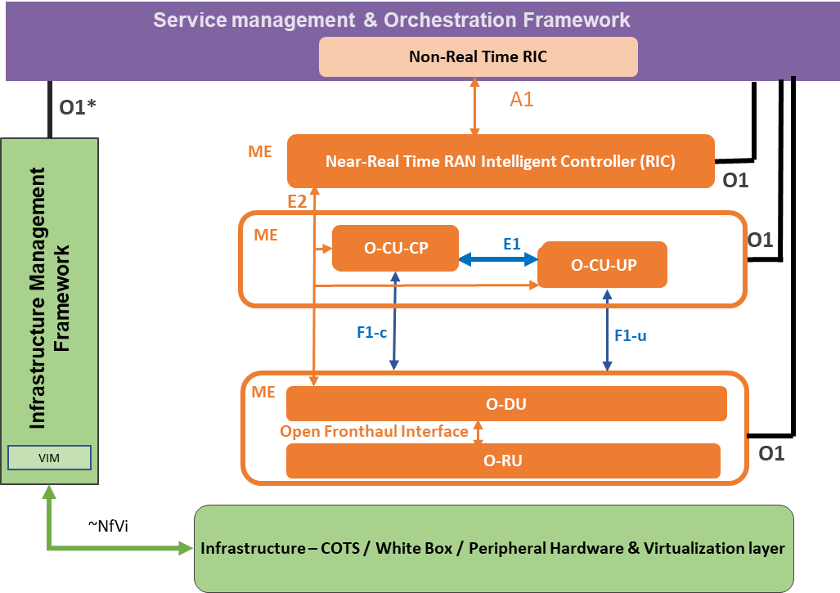

Figure 3 - A1 interface example

### xAPPs

xApps should be targeted for Release “A”. This includes open source sample xAPPs and platform applications that can we used for integration, testing, and demonstrations.

Sample xApp – Measurement analyzer xApp that computes KPIs from RNIB data (e.g., number of attached UEs) and provides them to a dashboard in the non-RT RIC

Sample xApp – UE Manager xApp to subscribe for E2 messages and read these E2 messages to extract information from specific information elements (IEs). The information shall be stored into the near-RT RIC database (RNIB). The RNIB reflects the most recent RAN information state.

AdmissionControl xApp - The admission control xApp’s role will be to control the rate of  admission of secondary NR bearers based on a specific criteria. This can be initially a very simple windowing algorithm based on rate of requests. In future, will be expanded to other overload/security scenarios.

The admission control xAPP will subscribe to SgNB addition requests and make binary decisions (accept/reject) for each request. It will  function in both report mode (where it simply logs decisions made) and also in control mode (for simulators) where it will send back a Request Ack or Reject message. The Admission control xApp will also have an interface to A1 (via the A1-mediator) to accept policies which change the windowing parameters

The Near RT-RIC should have a focus for this release. An initial framework should be put in place with support for xAPP development and operation.

#### The CU should target an initial software deliverables with limited functionality. This would be included as part of the integration and test plans.

* Near-RT RIC shall support Xapps in interpreting policies and intents
* Near-RT RIC shall support deployment and execution of xApps; Life cycle management (LCM) of Xapps (e.g., start/stop/deploy/undeploy)

Near-RT RIC platform (including the E2 manager) combined with dedicated xApps, like the UE manager xApp, should provide an up to date, consistent, and query-able view of UE and RAN config, context, state, and performance data to xApps running in the RIC; The RIC has a Radio Network Information Base (RNIB) which holds an accurate, updated information of the RAN (including GNB, ENB etc) state. The RNIB serves the needs of the various RIC components and xAPPs. We assume that whenever there is an update in the RAN state, the RIC receives REPORT or configuration update messages from the RAN over E2.

Near-RT RIC platform should support xApp execution to generate the corresponding RAN enforcement decisions.

* Near-RT RIC platform should be able to meet the necessary latency requirements for xApp execution (e.g., 10 msec)

### O-CU

The O-RAN CU is targeted for Release “A”.

#### The O-CU should recruit seed code contributions from contributors.

#### The O-CU should target an initial software deliverable with limited functionality.

#### O-CU shall implement a basic E2 interface. This would be included as part of the integration and test plans.

### O-DU

The O-RAN DU is targeted for Release “A”.

#### The DU should recruit seed code contributions from contributors.

#### The DU should target a proof of concept leveraging seed code contributions.

### O-RU

The O-RAN RU is not the focus of Release “A”.

#### The RU should focus plans for future releases.

## External and Common Software Projects

This chapter provides dependencies on other open source projects (Akraino, Acumos, ONAP, etc.) that need to be leveraged to realize an end-to-end ORAN deployment.

### Virtualization and acceleration Layer

### Operations, Administrations, and Maintenance (OA&M)

### Common Logging and Tracing

* Develop a standard logging mechanism

### Common Software Library and Tools.

* Develop an open source ASN.1 library

## Integration and Test “A” Objectives

The integration and test effort will focus on testing the requirements documented in each release. This will focus on end to end test and use case testing.

(E) testing shall primarily be done on the Akraino-REC (Radio Edge Cloud) blueprint.

### End to End O-RAN Use Case Testing

### Software testing should be covered by automated software testing using robot framework or other tools. <https://robotframework.org/>

* 1. OTF - Open Test Framework – a testing framework that allows plug-and-play of testing strategies

<https://wiki.onap.org/display/DW/OTF+-+Open+Test+Framework>

## Simulator Objectives

Simulators are very important to O-RAN Software Community. Developers and testers need simulators to allow the teams to work on parts of the software without having to have all part available. This is very important when RF interfaces and User Equipment (UE) interoperation are required.

In early releases simulators are very important to allow partial implementations of O-RAN interfaces and modules. The needs are to allow software to be developed with a reasonable level of isolation or until other software can be completed.

### Simulators for O-RAN components, interfaces, and messages.

#### E2 interface is needed for near RT-RIC and xAPPs. The E2 interface connects the RIC to the RAN Control Plane.

The set of E2 operations that need to be supported by the gNB simulator are

| Initiated by | Elementary Procedure | Initiating Message | Successful Outcome | Unsuccessful Outcome |
| --- | --- | --- | --- | --- |
| Response message | Response message |
| RIC | RIC Subscription (r1) | RIC SUBSCRIPTION REQUEST (r1) | RIC SUBSCRIPTION RESPONSE (r1) | RIC SUBSCRIPTION FAILURE(>r2) |  |
| RIC | RIC Subscription delete (r1) | RIC SUBSCRIPTION DELETE REQUEST (r1) | RIC SUBSCRIPTION DELETE RESPONSE (r1) | RIC SUBSCRIPTION DELETE FAILURE(>r2) |  |
| RIC or RAN | E2 Reset (r1) |  |  |  |  |
| RIC | E2 Setup (r1) | [EN-DC]/- X2 SETUP REQUEST | [EN-DC]/- X2 SETUP RESPONSE | [EN-DC]/- X2 SETUP FAILURE |  |
| RIC | Resource Status Reporting Initiation (r2) | RESOURCE STATUS REQUEST | RESOURCE STATUS RESPONSE | RESOURCE STATUS FAILURE |  |

| Initiated by | Elementary Procedure | Initiating Message | Which xApp? |
| --- | --- | --- | --- |
| RAN | RIC Indication | RIC INDICATION (r1) |  |
| RAN | Resource Status Reporting | RESOURCE STATUS UPDATE (r1) |  |
| RAN or RIC | Error Indication | ERROR INDICATION (r1) |  |

Legend: r1 is targeted for A release, r2 is B release

### Simulators for external components that interoperate with O-RAN

#### Not Required

### Simulators for User Equipment (UE)

#### Not Required

## Addendums

There will be different sections to support the document and its objectives.

### Contributors

|  |  |  |  |
| --- | --- | --- | --- |
| Name | Company | Contact Info |  |
| John Murray | AT&T | jfm@research.att.com | 5/5 |
| Rittwik Jana / David Kinsey / John Jensen | AT&T | [rjana@research.att.com](mailto:rjana@research.att.com) [dk8126@att.com](mailto:dk8126@att.com)  [jj2742@att.com](mailto:jj2742@att.com) | 6/10  ~~6/4~~ |
|  |  |  |  |
|  |  |  |  |
|  |  |  |  |

### Definitions

|  |  |
| --- | --- |
| Term | Description |
| Not Required | This release does not require any addition work on this topic for this release. The current software may be adequate or additional requirements may appear in the future. |
|  |  |
|  |  |
|  |  |
|  |  |
|  |  |
|  |  |

### Near-RT RIC component details

|  |  |  |  |  |
| --- | --- | --- | --- | --- |
|  | **Is docker container /binary?** | **Component** |  | **Description** |
| **Near-RT  RIC Platform** |  | xApp Manager |  | Manages xApps |
|  | Configuration Manager |  |  |
|  | Routing Manager |  |  |
| yes | E2 Termination |  | Setup E2 connection between RIC and gNB |
| yes | E2 Manager |  | Manages E2 connections |
| yes | DBaaS (Redis instantiation) |  | R-NIB |
| no, library | ASN.1 encoding/decoding library |  | Message library |
| no, library | AppPaaS - SDL (Shared data layer) |  | R-NIB database abstraction layer |
| no, library | AppPaas - Logging |  |  |
| no, library | AppPaaS - message library and routing table |  |  |
| no, library | OpenTracing |  |  |
|  | A1 Mediator |  | A1 interface impl. |
|  | VES agent |  | Collects PM data |
|  | UE manager |  |  |
|  | Subscription manager |  |  |
|  | DBaSS |  |  |
| **Aux** |  | VES collector |  |  |
|  | DMaaP |  |  |
| yes,in ONAP | RIC Dashboard |  |  |
|  | Nexus Repo for deployment |  |  |
| **xApps** | yes | Admission Control xApp |  |  |
| yes | Measurement reporting xApp |  |  |