FOCOM Services

Cloud Registration and Discovery
@startuml "Registration"
Box “Personnel” #lightblue
Actor “Cloud Install \nProject Mgr” as CloudOps
End box

box “FOCOM” <<SMO>> #gold
Database “Cloud Inventory” as CIDB
Boundary “Cloud LCM” as FOCOM
end box

box “SMO Integration Fabric” <<SMO>> #gold
Boundary “Log Store” as Grafana
end box

Box “O-Cloud Platform” #lightseagreen
participant “Genesis Server” as Genesis
Boundary “IMS” as IMS
Boundary “DMS ETSI” as Tacker
Boundary “DMS K8S” as K8S
Boundary “DMS OpenStack” as OpenStack
End box

ref over CloudOps, IMS #royalblue
**<back:royalblue><color: yellow> Reference: WG6 Orchestration and Use Case 3.1.3</color></back>**
End ref

CloudOps -> CIDB : POST ../Clouds
Return “globalCloudId”

Alt ManualRegistration
CloudOps -> FOCOM : POST
Note Right : ../Clouds/Register (globalCloudId, InternalCloudId, IMSendpoint)
FOCOM -> Genesis: Bootstrap
Else Genesis
CloudOps -> Genesis : Bootstrap
Note Right : (globalCloudId, callback=“../Clouds/Register”, Blueprint)
Genesis -> Tacker ** : activate
Genesis -> IMS ** : activate
IMS -> K8S: discover all k8s clusters
IMS -> IMS: add/update deployment Manager\n representing k8s as O2DMS\n in k8s native API profile
IMS -> Tacker: register k8s as O2DMS\n in ETSI NFV profile
IMS <-- Tacker: VimId
IMS -> IMS: add/update deployment Manager\n representing k8s as O2DMS\n in ESTI NFV profile
IMS -> OpenStack: discover all openstack instances
IMS -> Tacker: register openstack as O2DMS\n in ESTI NFV profile
IMS <-- Tacker: VimId
IMS -> IMS: add/update deployment Manager\n representing openstack as O2DMS\n in ESTI NFV profile
' Genesis -> K8S ** : activate
' Genesis -> Tacker : Configure (CISM=K8S, VIM=”K8S/kubevert”)
Genesis -> FOCOM : POST
Note Right : ../Clouds/Register (globalCloudId, InternalCloudId, IMSendpoint)
End if

FOCOM -> CIDB : PATCH
Note Right : ../Clouds/<globalCloudId> (InternalCloudId, IMSendpoint)
FOCOM -> IMS : GET <IMSendpoint>/InfrastructureInventory/v1/ResourceTypes
Loop Foreach ResourceType
FOCOM -> Grafana : POST
Note Right: Log ResourceType
End loop
FOCOM -> IMS : GET <IMSendpoint>/InfrastructureInventory/v1/Resources
Loop Foreach Resource
FOCOM -> Grafana : POST
Note Right: Log Resource
End loop
FOCOM -> IMS : GET <IMSendpoint>/InfrastructureInventory/v1/ResourcePools
Loop Foreach ResourcePool
FOCOM -> Grafana : POST
Note Right: Log ResourcePool
End loop
FOCOM -> IMS : GET <IMSendpoint>/o2ims-infrastructureInventory/v1/deploymentManagers
Note over FOCOM, IMS
DMS Attributes
ProfileType: K8S, K8s API endpoint, Capabilities={K8S,...}, Capacity=1, Location=us-central1
ProfileType: K8S, K8s API endpoint, Capabilities={K8S, Low Latency,...}, Capacity=2, Location=us-edge1
ProfileType: ESTI_NFV, Tacker API endpoint, Capabilities={ETSI, K8S}, Capacity=1,Location=us-central1
ProfileType: ESTI_NFV, Tacker API endpoint, Capabilities={ETSI, K8S, Low Latency}, Capacity=2,Location=us-edge1
ProfileType: ESTI_NFV, Tacker API endpoint, Capabilities={ETSI, OpenStack, Low Latency}, Capacity=3,Location=us-edge1
End note
Return
Loop Foreach discovered DMS
FOCOM -> Grafana : POST
Note Right: Log DMS
FOCOM -> CIDB : POST
Note Right : ../Clouds/DMS (DMSendpoint, Capabilities, Capacity)
Return DMSId
End loop

@enduml
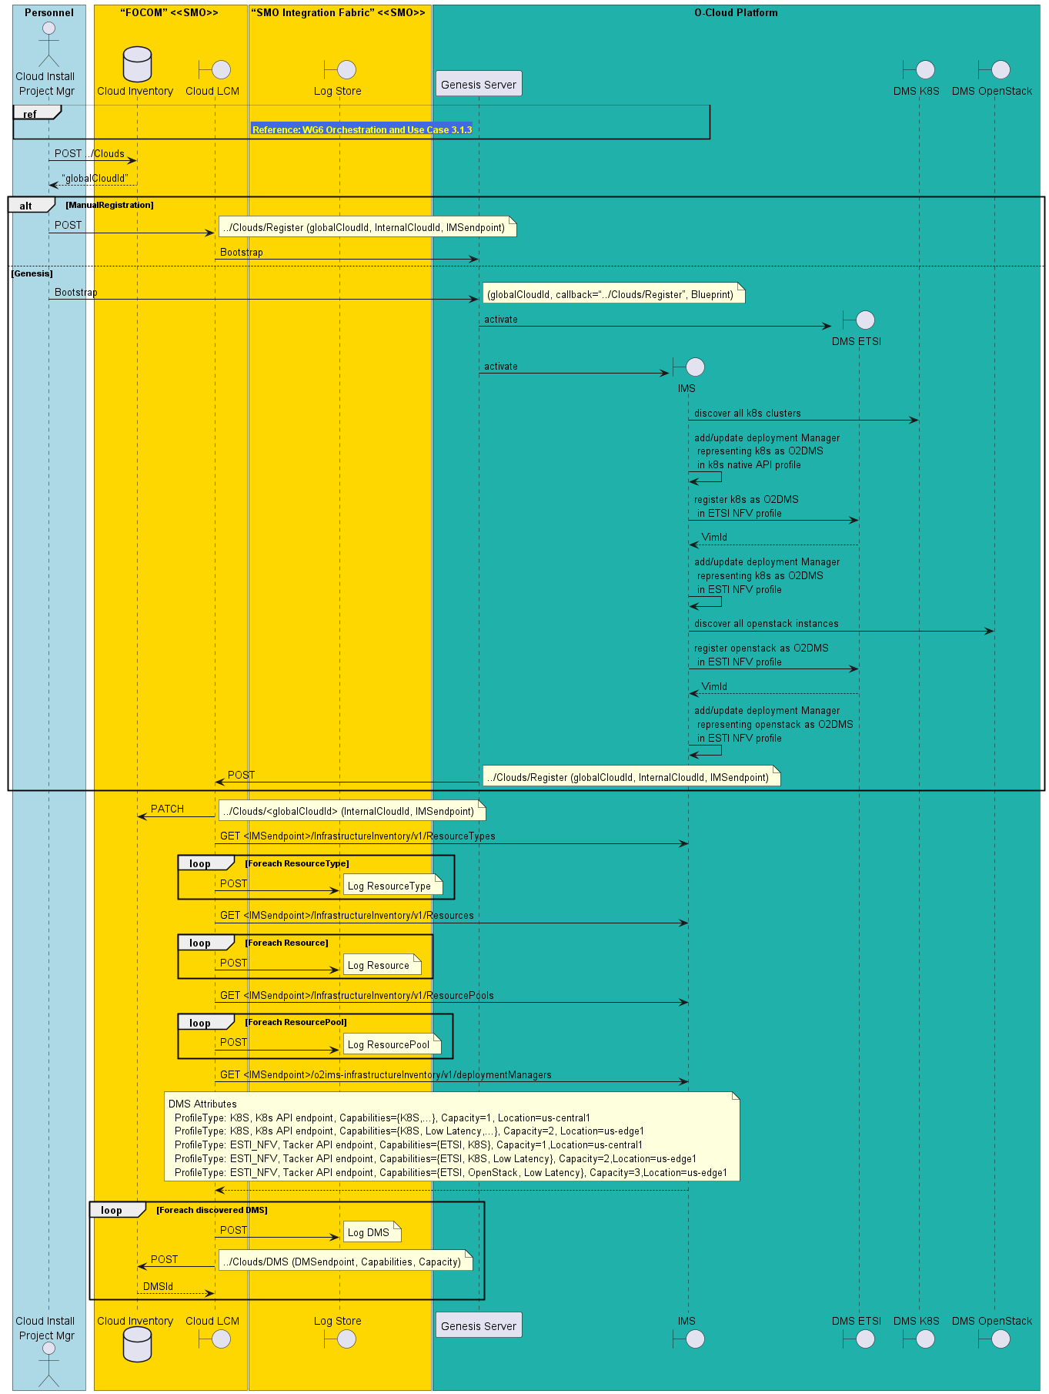

Homing
@startuml

box “FOCOM” <<SMO>> #gold
Database “Cloud Inventory” as CIDB
Boundary “Cloud LCM” as FOCOM
Boundary “Homing” as HOMING
end box

box “NFO” <<SMO>> #gold
Database “Deployment Inventory” as AppDB
Boundary “NF LCM” as NFO
end box

NFO -> NFO
Note Left : **Create Homing Demands:**\nforeach deployment item\n\tidentify LocationIdentifier\n\tidentify ProfileType\nend loop

NFO -> HOMING : Create Homing Plan

HOMING -> CIDB : GET all DMS

HOMING -> HOMING
Note Right : **Create Homing Plan:**\nforeach deployment item\n\tidentify DMS which matches\n\tLocationIdentifier and ProfileType\nend loop

HOMING --> NFO : return plan

@enduml
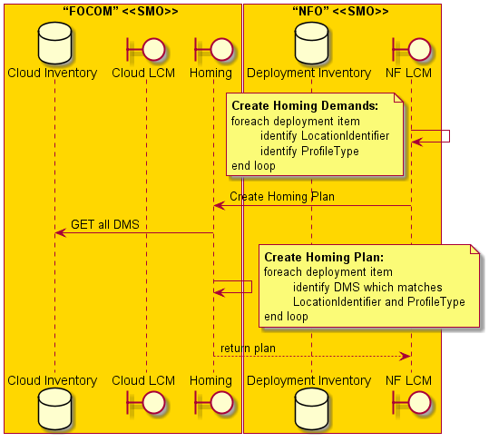

Orchestration
@startuml "Orchestration"

box “FOCOM” <<SMO>> #gold
Database “Cloud Inventory” as CIDB
Boundary “Cloud LCM” as FOCOM
end box

box “NFO” <<SMO>> #gold
Database “Deployment Inventory” as AppDB
Boundary “NF LCM” as NFO
end box

Box “O-Cloud Platform” #lightseagreen
Boundary “DMS ETSI” as Tacker
Boundary “DMS K8S” as K8S
Boundary “DMS OpenStack” as OpenStack
End box

NFO -> NFO: orchestrate workload by homing plan

NFO -> CIDB : Get O2DMS by DMSid
NFO <-- CIDB: O2DMS API endpoint\n (either DMS K8S API endpoint or DMS ESTI API endpint)

Alt DMS in K8S Profile
NFO -> K8S: deploy workload via K8S APIs
NFO -> K8S: query workload resources
NFO -> AppDB: update inventory
ELSE DMS in ESTI Profile
NFO -> Tacker: deploy workload via ETSI NFV APIs

Alt k8s workload
Tacker -> K8S: deploy workload via K8S APIs
ELSE OpenStack workload
Tacker -> OpenStack: deploy workload via OpenStack APIs
End if

NFO -> Tacker: query workload resources
NFO -> Tacker: update inventory

End if

@enduml

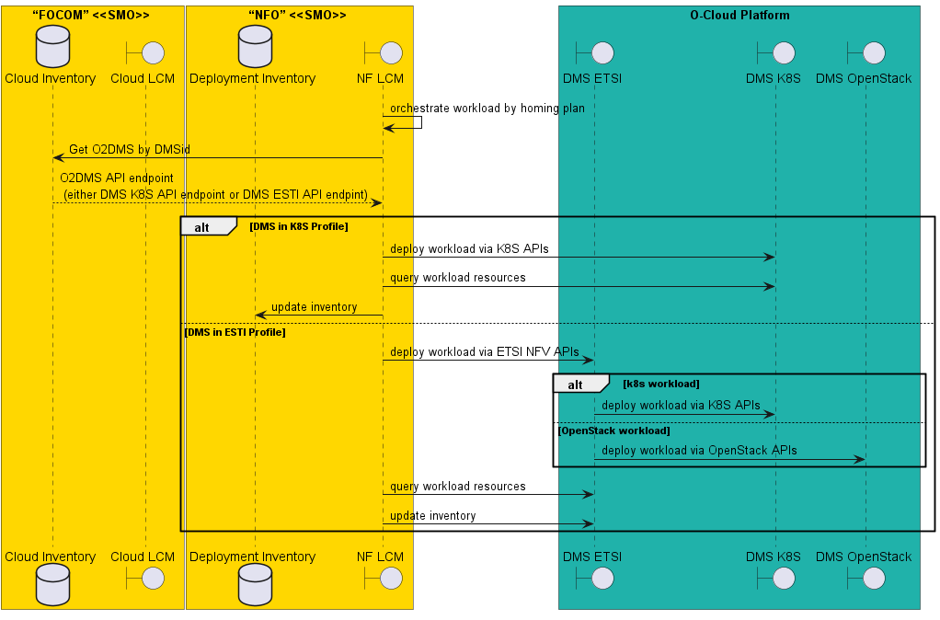

@startuml
Box “Personnel” #lightblue
Actor “Cloud Install \nProject Mgr” as CloudOps
Actor “NF Install \nProject Mgr” as NFOps
End box

box “FOCOM” <<SMO>> #gold
Database “Cloud Inventory” as CIDB
Boundary “Cloud LCM” as FOCOM
Boundary “Homing” as HOMING
end box

box “NFO” <<SMO>> #gold
Database “Deployment Inventory” as AppDB
Boundary “NF LCM” as NFO
end box

box “OAM” <<SMO>> #gold
Boundary “VES Collector” as VES
Boundary “NETCONF Client” as SDNR
end box

Box “RAN PM” <<SMO>> #gold
Database “Telemetry Store” as InfluxDB
End box

Box “RAN FM” <<SMO>> #gold
Database “Event Store” as AlarmDB
End box

Box “RAN CM” <<SMO>> #gold
Database “Config Persistent Store” as CPS
End box

box “SMO Integration Fabric” <<SMO>> #gold
Boundary “Message Bus” as Kafka
Boundary “Log Store” as Grafana
end box

Box “O-Cloud Platform” #lightseagreen
participant “Genesis Server” as Genesis
Boundary “DMS ETSI” as Tacker
Boundary “DMS K8S” as K8S
Boundary “IMS” as IMS
End box

Box “O-RAN” #lightpink
Participant “CNF” as CNF
Participant “CNF\nComponent” as CNFC
end box

NFO -> NFO
Note Right : **Create Homing Demands:**\nforeach deployment item\n\tidentify LocationIdentifier\n\tidentify ProfileType\nend loop

NFO -> FOCOM : Create Homing Plan

FOCOM -> CIDB : GET all DMS

FOCOM -> FOCOM
Note Right : **Create Homing Plan:**\nforeach deployment item\n\tidentify DMS which matches LocationIdentifier and ProfileType\nend loop

FOCOM --> NFO : return plan

@enduml
