**PROJECT PROPOSAL 🡪 Non Real-Time RAN Intelligent Controller (RIC non-RT)**

**O-RAN Software Community Release A**

**Project Name:**

* Proposed name for O-RAN SC project: Non Real-Time RAN Intelligent Controller (RIC non-RT)
* Proposed name for the repository: non-rt-ric

**Project description**:

The primary goal of RIC non-RT is to support non-real-time intelligent radio resource management, higher layer procedure optimization, policy optimization in RAN, and providing AI/ML models to RIC near-RT.

With the amount of L1/L2/L3 data collected from eNB/gNB (including CU/DU), useful data features and models can be learned to empower the intelligent management and control in RAN. For example, network spatial-temporal traffic patterns, user mobility patterns, service type/patterns along with the corresponding prediction models, network quality of service (QoS) prediction patterns, massive MIMO parameters configuration, and more can be learned and trained based on the big data analytics and machine learning. These well-learned data features and models are undoubtedly helpful for driving fine-grained near-real-time network radio resource management in the RIC near-RT and non-real-time optimization within RIC non-RT.

The A1/O1 interface supports communication & information exchange between Orchestration/NMS layer (ONAP) containing RIC non-RT and eNB/gNB containing RIC near-RT.

Key functions that the A1 &O1 interfaces are expected to provide include:

* Network & UE-level information/context exposure from eNB/gNB to RIC non-RT to support various requirements such as network management, online learning and offline training of AI/ML models and driving non-RT optimization into the network.
* Support for policy-based guidance of RIC near-RT functions/use-cases, deploying/updating AI/ML models into RIC near-RT, and feedback mechanisms from RIC near-RT to ensure SLAs.

The proposed RIC non-RT project within ORAN SC release A integrates the A1 and O1 interfaces from O-RAN with ONAP release 4 Dublin in order to support and demonstrate 5G use cases from both communities.

Further Integration with Acumos and Akraino is also anticipated.

**Scope:**

The following features are in scope for the RIC non-RT project within O-RAN SC release A:

* Enhancements to support O-RAN SC release A use cases that can be delivered “on top of” ONAP release 4 Dublin (in other words, without Dublin code impacts):
  + Yang models based on O-RAN IM/UML or YANG files imported from O-RAN WGs
  + Directed graphs
  + New Adapters needed to support use cases (details to be determined during planning phase)
  + Netconf, Ansible, and Chef interfaces
  + ML model catalogue access for non-RT RIC to perform model training (details to be determined during planning phase based on identified use cases)
  + Non-real-time automated control via CM changes in network functions based on O-RAN Yang model as an output of the non-RT RIC analytics service (ML-assisted or otherwise, exact use case to be determined during planning phase)
* Support for third party controllers
  + Adapter to allow DG to connect to NetConf devices
* High availability (local)
* The following features will be defined for this project:
  + Configuration versioning: ability to roll back the configuration
  + Support for third party controllers (???)
    - Adapter layer to interface with downstream controllers
  + Support for geographically distributed network resources



**Architecture Alignment:**

**How does this project fit into the rest of the O-RAN Architecture?**

This project uses the O-RAN A1/O1 interface specifications to integrate wireless xNFs with RIC non-RT which is a component within the Orchestration & Automation layer depicted within the O-RAN architecture diagram below:

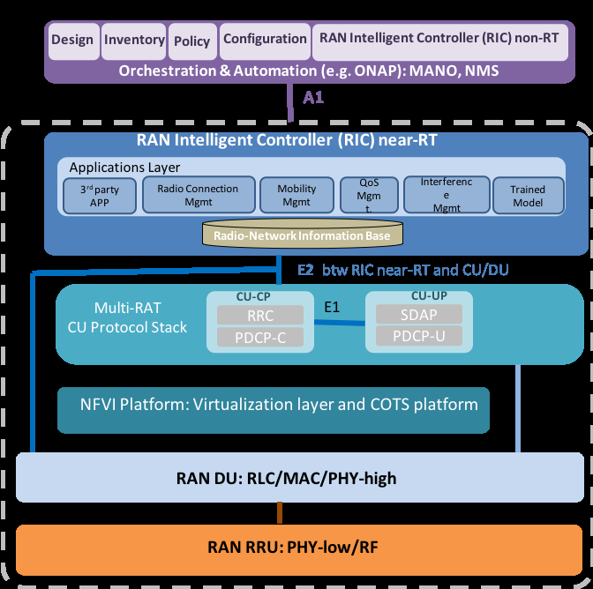

RIC non-RT will be built on ONAP release 4 Dublin within OSC Release A, and it is intended to be used within ONAP; however, there are other options within the Orchestration & Automation layer that are to be addressed within subsequent OSC releases.

**How does this align with external standards/specifications?**

NETCONF, YANG, and the O-RAN Information Model (OIM) for control of multi-vendor wireless network elements through open management interfaces, as defined in O-RAN WG interface specifications.

**Are there dependencies with other open source subprojects?**

* Acumos
* Akraino
* Open Daylight
* ONAP
* Open Networking Foundation
* OPNFV
* Open RAN Alliance

**Resources:**

Project Technical Lead (PTL): Martin Skorupski, [martin.skorupski@highstreet.com](mailto:martin.skorupski@highstreet.com)

Names, gerrit IDs, and company affiliations of the committers:

George Clapp (AT&T), [clapp@research.att.com](mailto:clapp@research.att.com)

Dongho Kim (AT&T), [dk5913@att.com](mailto:dk5913@att.com)

Herbert Eiselt (highstreet), [herbert.eiselt@highstreet-technologies.com](mailto:herbert.eiselt@highstreet-technologies.com)

Raymond (Zach) Lovell (CommScope), [Zach.Lovell@commscope.com](mailto:Zach.Lovell@commscope.com)

**<completion of roster in progress>**

Names and affiliations of any other contributors (in alphabetical order):

Dhruv Gupta (AT&T), [dg285u@att.com](mailto:dg285u@att.com)

Thorsten Heinze (Telefonica), [thorsten.heinze@telefonica.com](mailto:thorsten.heinze@telefonica.com)

Petr Jurcik (DTAG), [petr.jurcik@t-mobile.cz](mailto:petr.jurcik@t-mobile.cz)

Lyndon Ong (Ciena), [lyong@ciena.com](mailto:lyong@ciena.com)

Morgan Richomme (Orange), [morgan.richomme@orange.com](mailto:morgan.richomme@orange.com)

Slawek Stawiarski (AT&T), [ss8631@att.com](mailto:ss8631@att.com)

Tracy Van Brakle (AT&T), [vanbrakle@att.com](mailto:vanbrakle@att.com)

**<completion of roster in progress>**

**Key Subproject Facts**

**Subproject Name:**

JIRA subproject name: non-rt-ric

JIRA subproject prefix: non-rt-ric

**Repo name:**

org.sc,oran,ric.rl.non/…

**Lifecycle State: incubation**